TO AREA MEETING CLERKS

Annual Conference of Treasurers
27th June 2015
Friends House, London

The power of money: Living out our faith in the world – spending the Quaker pound

Dear Friend,

The 2015 Annual Conference of Treasurers will be held on Saturday 27th June in the newly refurbished Large Meeting House in Friends House, London.

Your Area Meeting is invited to nominate and pay for Treasurers and/or other holders of financial roles to attend this event. Most AMs aim to send two Friends but if you would like to send more that’s fine. The cost of the conference is £25 per person. We ask your area meeting to consider this matter and to complete the online appointments form, as soon as possible. The deadline for bookings is 10th April 2015. The online form can be found at http://www.quaker.org.uk/annual-conference-treasurers.

If you do not have access to the internet, please send the name and contact details of the Friend(s) to me at the address below.

The Annual Conference of Treasurers meets each year to support Friends involved in financial activities, to get together to share problems and solutions, exchange ideas, make new contacts, hear about current issues and review the financial results of Britain Yearly Meeting. It is a chance to meet other treasurers: to confer with them on any issue of interest or concern and to share insights. Treasurers, trustees and other meeting officers of all levels of experience find the conference both rewarding and uplifting.

This year we hope to look at issues such as ethical banking, encouraging contributions, spending on sustainability and the right use of our reserves. We will also have a number of technical workshops designed to give practical assistance to Friends.

I do hope that your Area Meeting is able to benefit from sending at least one Friend to this event.

In friendship,

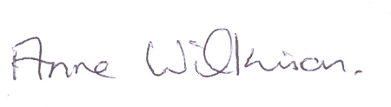

Anne Wilkinson
Events & Committee Services
annew@quaker.org.uk
0207 663 1062

